C195 – Software II

Project Documentation

Daniela Vidal Canas

Student ID: 001172091

**A. Create a log-in form that can determine the user’s location and translate log-in and error control messages (e.g., “The username and password did not match.”) into two languages.**

|  |  |
| --- | --- |
| **English** | **Spanish** |
|  |  |
|  |  |

**Code:**

* C195.src.c195.login.LoginController.java (Line 76)
* C195.src.c195.util.lang.NAT_en.properties (English)
* C195.src.c195.util.lang.NAT_es.properties (Spanish)

**B. Provide the ability to add, update, and delete customer records in the database, including name, address, and phone number.**

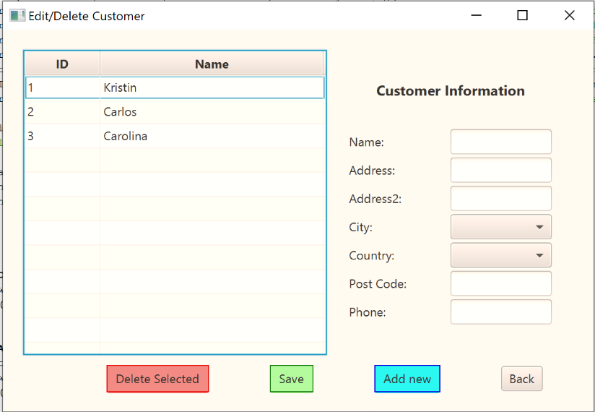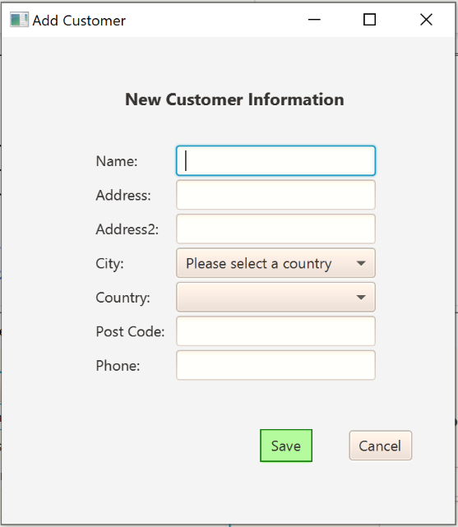

**Code:**

* Add:
  + C195.src.c195.customer.CustomerController.Java (Line 141)
  + C195.src.c195.customer.CustomeraddController.Java (Line 52)
* Update: C195.src.c195.customer.CustomerController.Java (Line 111)
* Delete: C195.src.c195.customer.CustomerController.Java (Line 83)

**C. Provide the ability to add, update, and delete appointments, capturing the type of appointment and a link to the specific customer record in the database.**

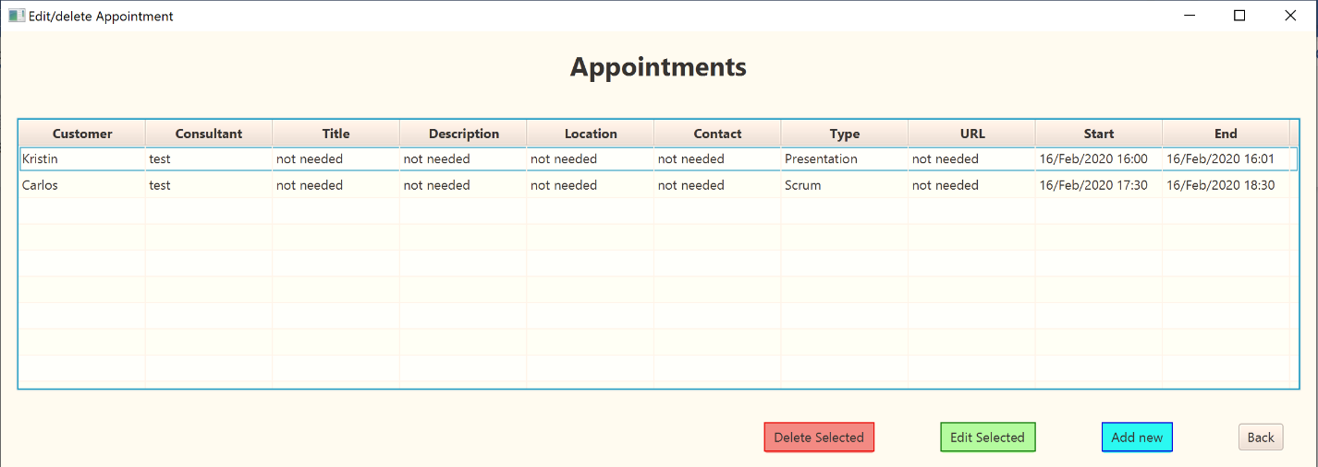

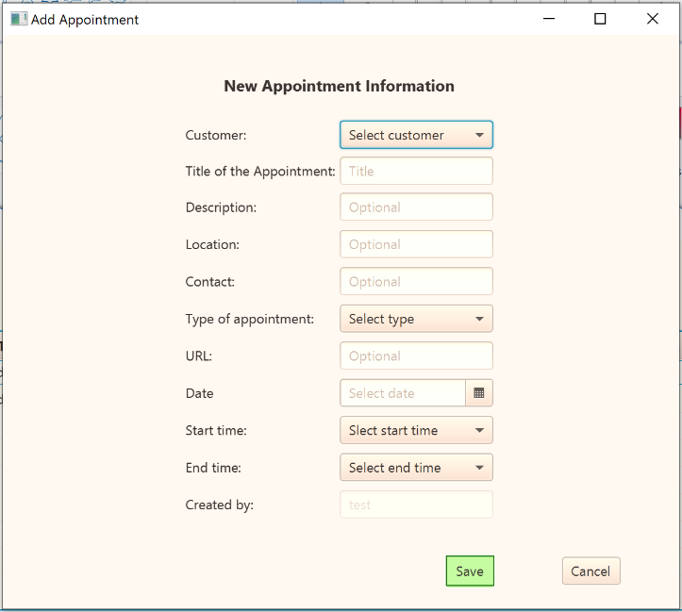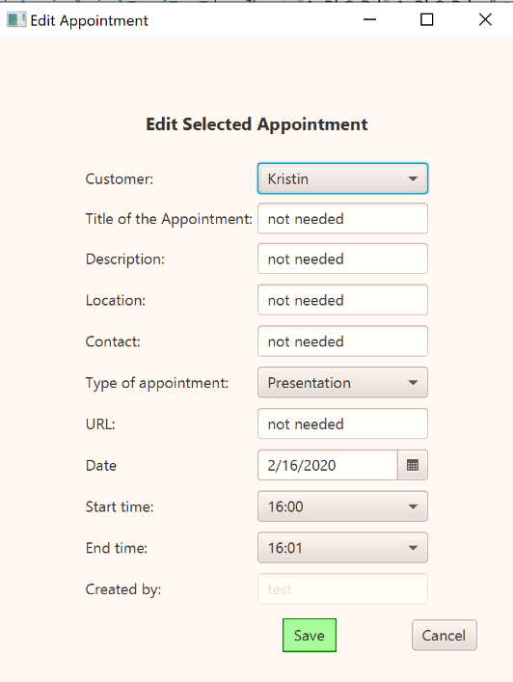

**Code:**

* Add:
  + C195.src.c195.appointment.AppointmentController.Java (Line 109)
  + C195.src.c195.appointment.AppointmentaddController.Java (Line 48)
* Update:
  + C195.src.c195.appointment.AppointmentController.Java (Line 96)
  + C195.src.c195.appointment.AppointmenteditController.Java (Line 90)
* Delete: C195.src.c195.appointment.AppointmentController.Java (Line 77)

**Note:**

* The showed appointments are relevant to the current consultant, other appointments are not shown (but can be checked on ‘appointment by consultant’ report)

**D. Provide the ability to view the calendar by month and by week.**

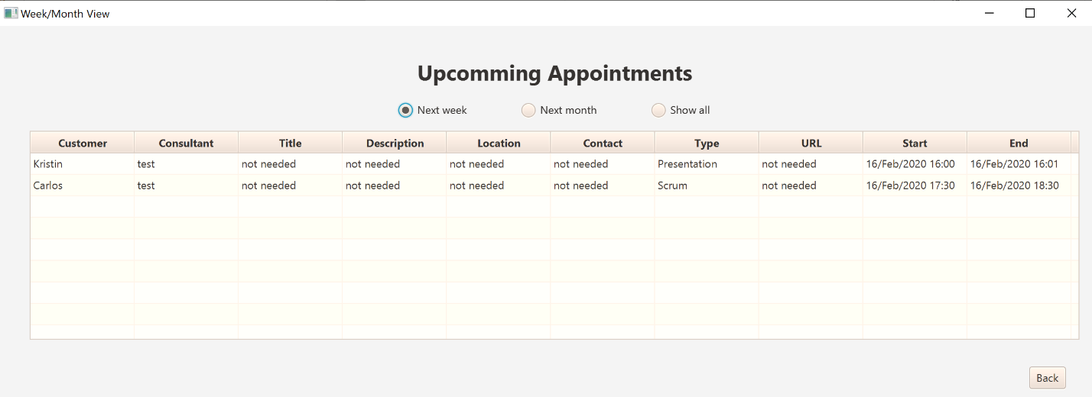

**Code:**

* C195.src.c195.appointment.AppointmentFilteredController.Java (Line 65)
* C195.src.c195.appointment.AppointmentFilteredController.Java (Line 81)
* C195.src.c195.appointment.AppointmentFilteredController.Java (Line 87)
* C195.src.c195.appointment.AppointmentFilteredController.Java (Line 93)

**Note:**

* The showed appointments are relevant to the current consultant, other appointments are not shown (but can be checked on ‘appointment by consultant’ report)

**E. Provide the ability to automatically adjust appointment times based on user time zones and daylight saving time.**

**Code:**

* C195.src.c195.dataprovider.DataProvider.Java (Line 81 and 99)

**Note:**

* The showed appointments are relevant to the current consultant, other appointments are not shown (but can be checked on ‘appointment by consultant’ report)

**F. Write exception controls to prevent each of the following. You may use the same mechanism of exception control more than once, but you must incorporate at least two different mechanisms of exception control.**

• scheduling an appointment outside business hours

**Note:** Not possible the schedule an appointment outside business hours, ComboBox to select time of start/end does not display such option

• scheduling overlapping appointments

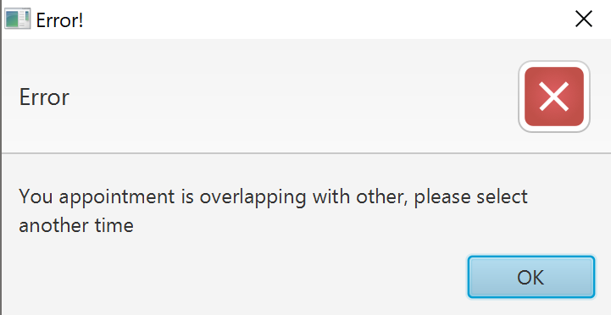

**Code:**

* C195.src.c195.dataprovider.DataProvider.Java (Line 110)
* C195.src.c195.dataprovider.DataProvider.Java (Line 133)

• entering nonexistent or invalid customer data

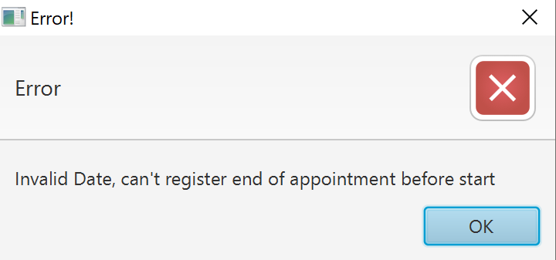

**Code:**

* C195.src.c195.dataprovider.DataProvider.Java (Line 154)

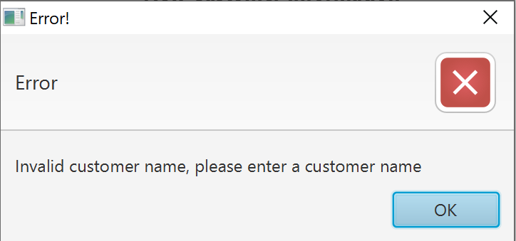

**Code: (ADDED AFTER 1ST ATTEMPT)**

* C195.src.c195.dataprovider.DataProvider.Java (Line 405)

• entering an incorrect username and password

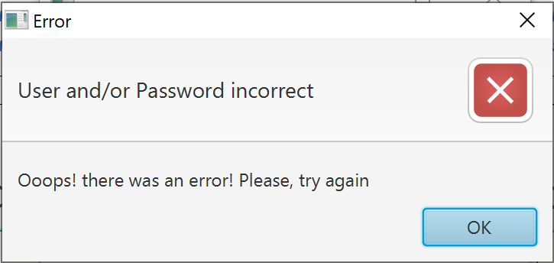

**Code:**

* C195.src.c195.login.LoginController.java (Line 62)

**G. Write two or more lambda expressions to make your program more efficient, justifying the use of each lambda expression with an in-line comment.**

**Code:**

* LAMBDA EXPRESSION: used to get a list of results of the required type as soon as the query is executed. With this we avoid writing the code multiple types everything stays in the business logic
  + Definition:
    - C195.src.c195.util.Query.Java (Line 46)
  + Use (some):
    - C195.src.c195.dataprovider.DataProvider.java (Line 223)
    - C195.src.c195.dataprovider.DataProvider.java (Line 239)
    - C195.src.c195.dataprovider.DataProvider.java (Line 272)
* LAMBDA EXPRESSION: a lambda expression that simplify getting the int ID from any table where a specific condition is met
  + Definition:
    - C195.src.c195.dataprovider.DataProvider.java (Line 47)
  + Use (some):
    - C195.src.c195.customer.CustomerController (Line 122 and 123)
    - C195.src.c195.customer.CustomerAdd.Controller(Line 65)
    - C195.src.c195.appointment.AppointmentAddController(Line 54 and 55)

**H. Write code to provide an alert if there is an appointment within 15 minutes of the user’s log-in.**

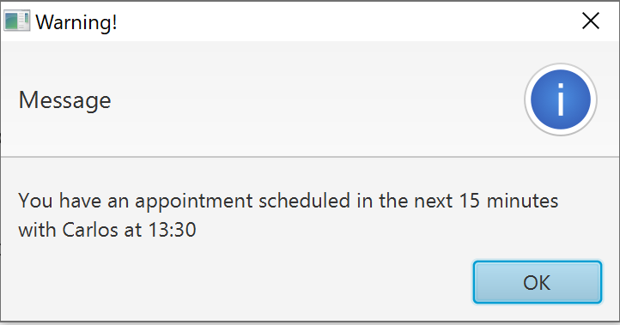

**Code:**

* C195.src.c195.dataprovider.DataProvider.Java (Line 195)

**I. Provide the ability to generate each of the following reports:**

• number of appointment types by month

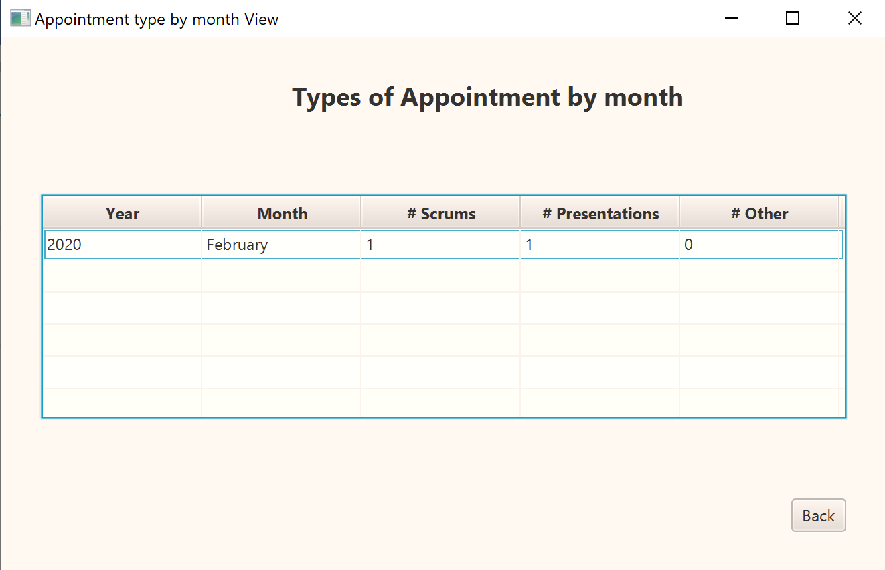

**Code:**

* C195.src.c195.reports.TypeByMonthController.Java (Line 47)

• the schedule for each consultant

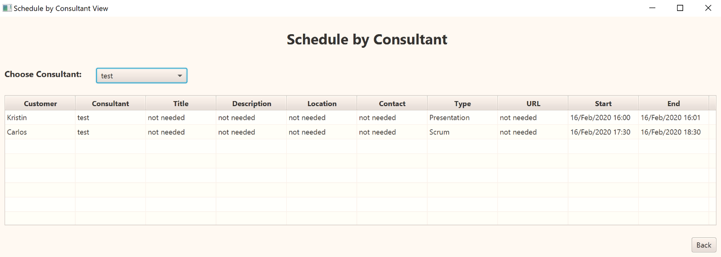

**Code:**

* C195.src.c195.reports.SchByUserController.Java (Line 48)
* C195.src.c195.reports.SchByUserController.Java (Line 74)

• one additional report of your choice

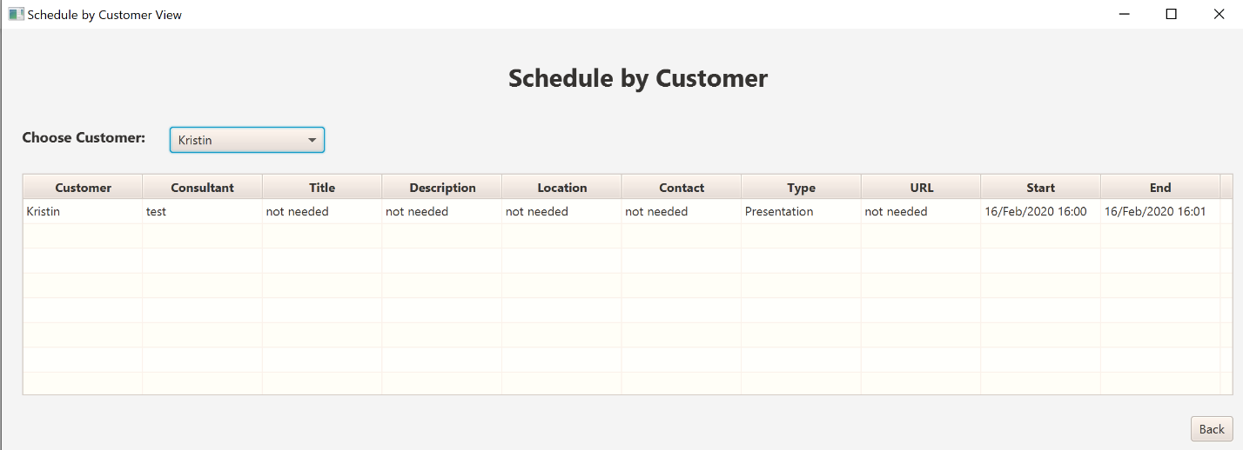

**Code:**

* C195.src.c195.reports.SchByCustomerController.Java (Line 48)
* C195.src.c195.reports.SchByCustomerController.Java (Line 70)

**J. Provide the ability to track user activity by recording timestamps for user log-ins in a .txt file. Each new record should be appended to the log file, if the file already exists.**

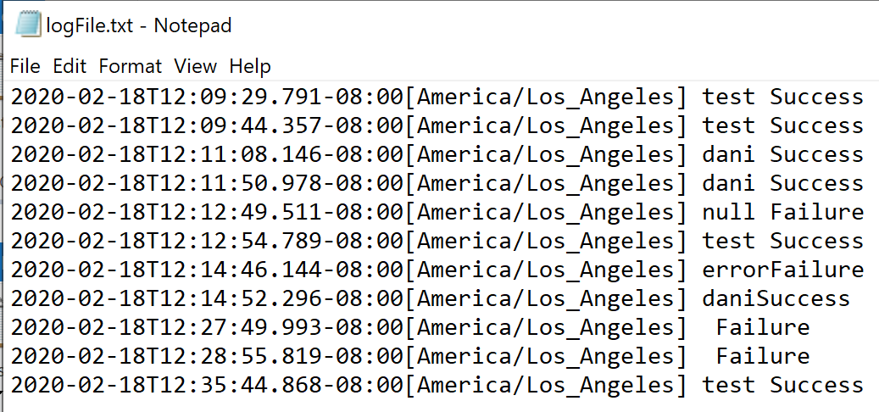

**Code:**

* C195.src.c195.dataprovider.DataProvider.Java (Line 363)
* C195.src.c195.dataprovider.DataProvider.Java (Line 371)